Software Design Document
For
ACDS (Assignment Collection and Distribution System)
Version 1.0 approved
Prepared by
M S Karim, S Kachhipati, M M Alam and M R A Mollah

Dream Builders
May 19, 2006

Table of Content

1. Introduction 3
2. Document Description 3
2.1. Purpose 3
2.2 The Audiences 4
3. Scope 4
3.1. Document Scope 4
3.2. Project scope 5
4. System overview 6
5. Design process 7
5.1. Database design 9
5.2. Required Database Specification 11
6. Website design 16
6.1. Considerations 17
6.2. Hardware Requirements 17
6.3. Software Requirements 18
7. Site content 19
7.1. Content Inventory 19
7.2. Categories and labeling 20
7.3. Functional Requirements 21
8. Structure layout 24
8.1. Home page Error! Bookmark not defined.
8.2. Site map 24
9. Security Issues 25
10. Navigational Systems 25
11. Content design 26
12. Design Constraints 27
13. Prototypes 29
14. Backup and recovery strategy 47
14.1. Backups 47
14.2. Recovery strategies 50
15. Test plans and procedures 51
16. Acceptance plan 53
16.1. Installation 53
16.2. Acceptance criteria 54

Introduction

Our project has been developed with the purpose of ACDS (Assignment Collection and Distribution System). Here this document represents SDD (Software Design Document), which provides an overall idea of architectural designs that have been used to develop the entire project. This document aims to create a modular decomposition of the product that is being under development. So here in this document we are going to incorporate all documents of our project in a design view.

Document Description

Purpose

The design document is a coherent set of abstract patterns guiding the design from each aspect of a large software system. University of Ballarat at IIBIT is currently using a semi-automatic hard copy of assignment submission and collection system for the students, which is complicated and time consuming. So the idea is to develop a system more reliable and secured by applying new technology.

This document is going to be a set of requirements with the specification document that describes a high level appropriate modules, data structures, databases and interfaces. The Detailed Design Document is formally written before programming starts. It describes how the software will be structured, and what functionality will be included. This document forms the basis for all future design and coding.

The Audiences

The Audiences of this document includes,
- Client
- Supervisor
- Team members
- Future developers
- End users

Scope

Document Scope
This document contains a complete description of the design of (ACDS) Assignment Collection and distribution System. The basic architecture is a whole idea how the system is being implemented. Moreover design detail primarily focuses on the system overview of database design, code implementation, barcode and new software used to develop this system in this project.

Project scope
University of Ballarat at IIBIT is currently using a semi-automatic hard copy of assignment submission and collection system for the students, which is complicated and time consuming. So the idea is to convention the system more reliable and secured by applying new technology. The Dream builders’ came with new talent and their project criteria to solve this problem.

The system will work using barcode that will be generated for every assignment (hard copy) submitted. In the event of not using scanner the system user will be able to enter barcode number manually.

The web application will basically list all the courses, assignment (hard copy) types, due dates, and other information from the database.

The scanned information will be stored in the database system. The stored assignment (hard copy) information will be collected and distributed to the concerned lecturers and tutors.

System overview

The new system will be consisted the following features

Assignment collection from student

- System will allow user (staff) to login first.
- For hard copy of assignment collection, system will allow user (staff) to input student detail and system will check validation for enrollment.
- Then system will allow user (staff) to select assignment no and to enter the barcode using either barcode scanner or keyboard.
- By this time system will check the due date and submission date and ask for whether there is any special consideration. Then system will calculate for any penalty.
- Then system will allow user (staff) to submit the assignment and store data in the integrated database.
- At last, the system will print a copy of receipt for the student.

Assignment Distribution to the tutors
- System will allow user (staff) to select a tutor from the drop down list assign any number of assignments to the lecturers or tutors. System will update those assignments to the database

Assignment Collection from the tutors
- System will allow user (staff) to update the database when the assignment will be collected from the tutor.

Assignment Redistribution to the moderator
- System will allow user (staff) to select from the drop down list and assign any number of assignment to a moderator. System will update the assignment has been selected for moderation in the database.

Assignment return to student
- Finally, system will allow user to update the database, store the obtained marks in the assignment by the respective student and return the assignment to the students.

Design process
UML provides mechanisms for describing requirements and OO solutions to those requirements. The language also, through Use Cases, facilitates the move from requirements into design providing some degree of traceability between the two.
As we all in the team are more familiar with the UML (unified modeling language) process so we came to a team decision to follow the UML standards to develop the design of the software. The basics of the UML are stated below,

- Use case diagrams
- Class Diagrams
- Sequence Diagrams / Interaction diagrams
- Collaboration Diagrams

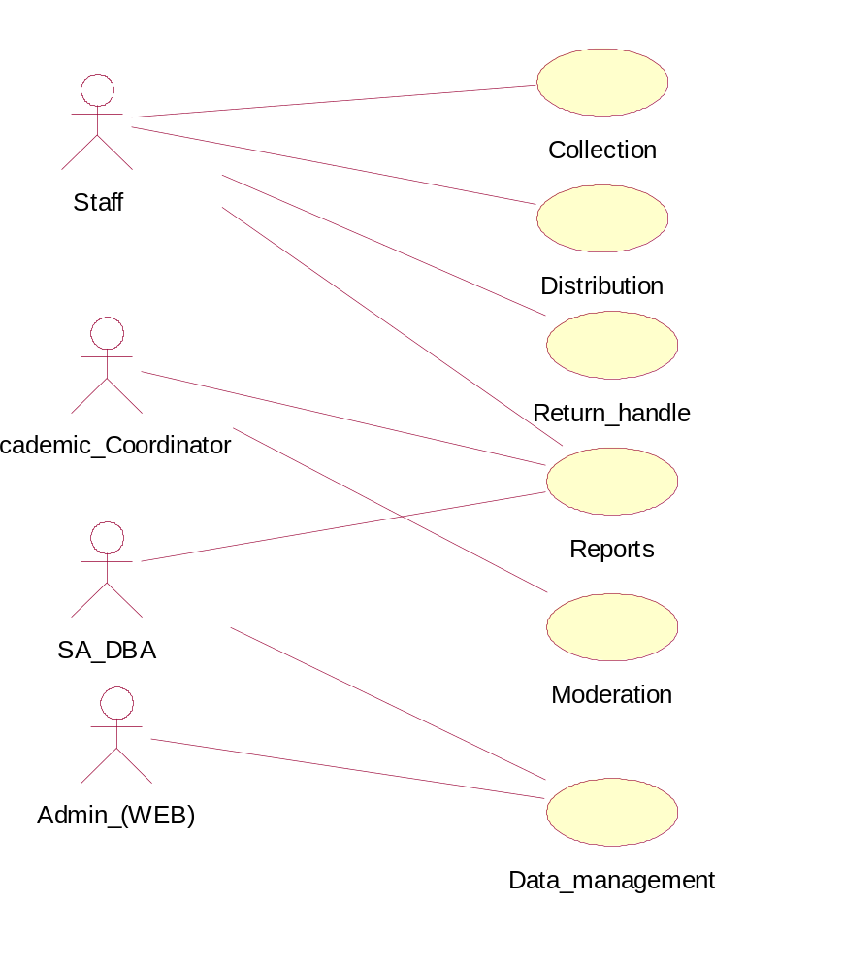
ACDS

Figure 1: Use case Diagram for ACDS
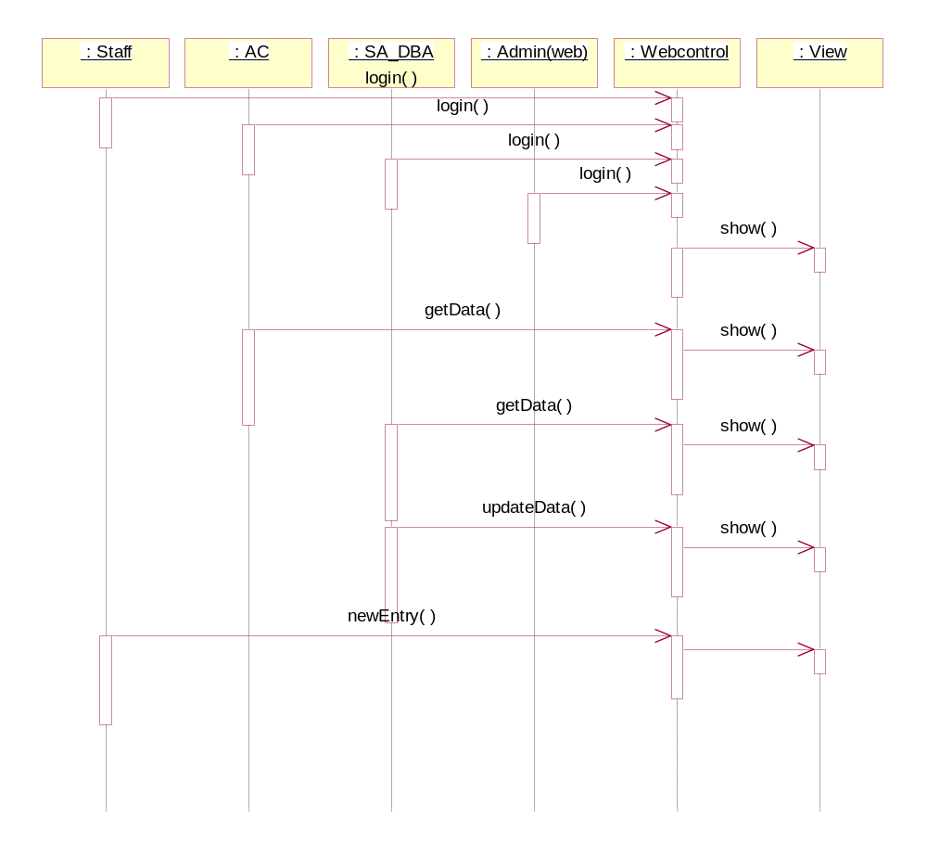
Figure 2: Sequence Diagram for ACDS
New Collection state chart diagram:
Distribution state chart diagram:
Data Management state chart diagram:
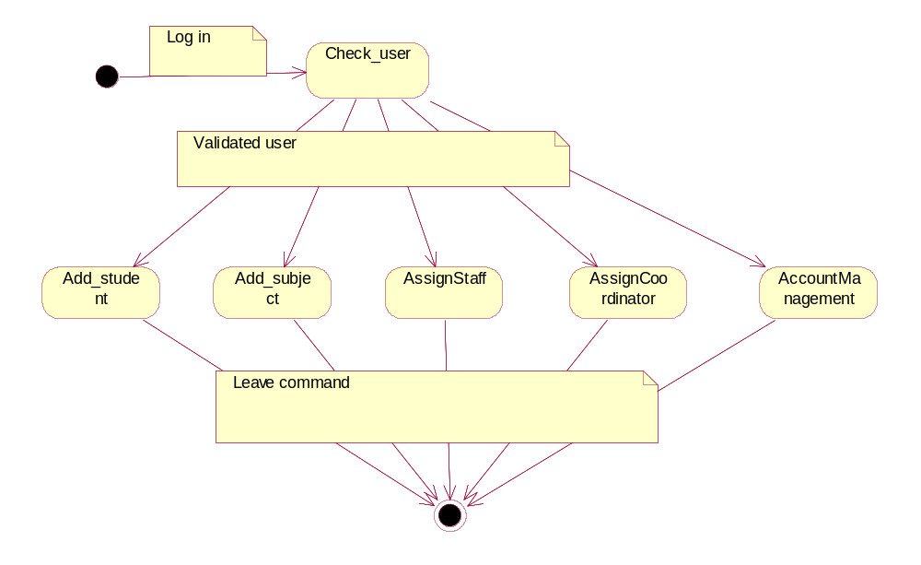
Moderation state chart diagram:
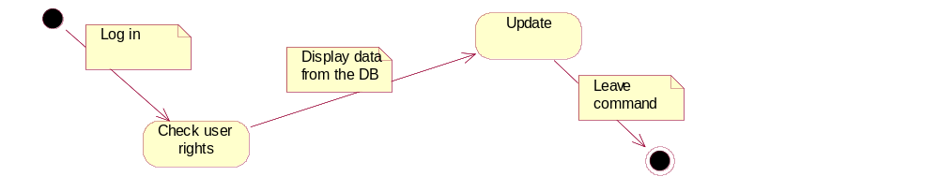
Report state chart diagram:
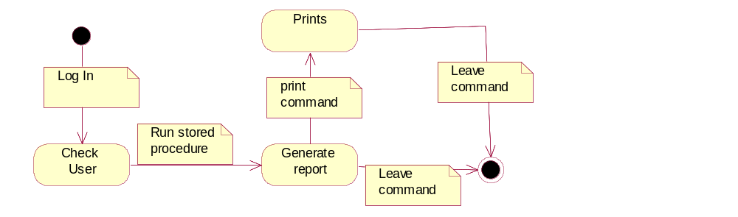
Return state chart diagram:
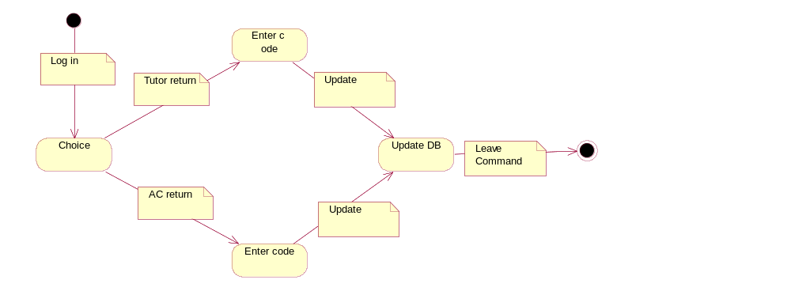

Database design
Database design is the process of producing a detailed data model of a database. This model contains all the needed physical design choices that can make the information system static. A fully attributed data model contains detailed attributes for each entity.

The database used for this project will be most popular SQL server database. In order to make the new system more organized we need the better use of database system by the appropriate designer from one of our team member who has special knowledge about this.

An effective, usable database is only possible if its designers have adequately incorporated the results of a full needs and task analysis.

As we started to develop our new ACDS system, using database early on so we went through some steps in order to develop database for our entire project,
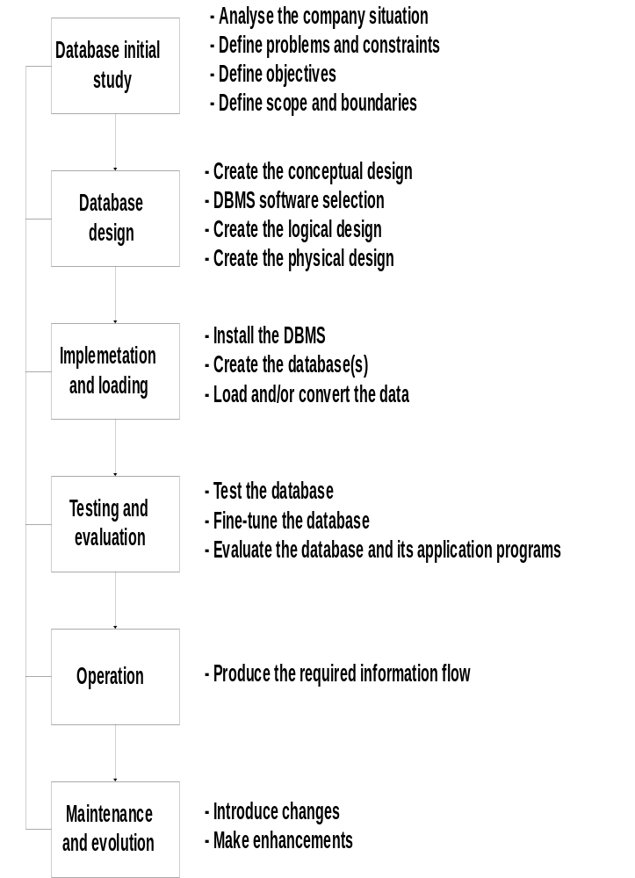

ER-Diagram

COLLECTION

Collection No

Staff_Id

Assesment_code

Submission_Date

Special_Consideration

Number_Of_Days_Late

DISTRIBUTION

Transaction_Code

Collection No

Staff_Id

Due_Date
MORDERATION

Unique No

Collection No

Staff_Id

RESIDENCE

Residence_No

Unit _No
House _No
Suburb
City
Country
Phone
STUDENT

Student Id

Course_Code

Unique_Id

UNIT_TUTOR

Unique Serial

Subject _Code

Staff_Id

STAFF

Staff Id
Unique Id
UNIT_COORDINATOR

Serial Number

Subject _Code

Staff_Id

PERSON

Unique Id First_Name
Last_Name
Email
Residence_No

Mail_No

MAILADDRESS

Mail No

Unit _No
House _No
Suburb
City
Country
Phone
ENROLLMENT

Enroll No

Course_Code

Subject_Code

Student_Id

Semester

Session_Year
SUBJECT

Subject_Code

Subject_Name

Course _Code

COURSE

Course_Code

Course_name

ASSESMENT

Assesment_Code

Type

Due_Date

Subject_Code

Required Database Specification
Relational Database Schema:

Table Name | Field | Type | Description
STAFF_TABLE | Staff_Id  Street | Text  Number | Primary Key  Normal attributes

Table Name | Field | Type | Description
UNIT_TUTOR_TABLE | Unique Serial  Subject _Code  Staff_Id | Auto Number  Text  Text | Primary Key  Normal attributes  Foreign Key

Table Name | Field | Type | Description
UNIT_COORDINATOR | Serial Number  Subject _Code  Staff_Id | Auto Number  Text  Text | Primary Key  Normal attributes  Foreign key

Table Name | Field | Type | Description
PERSON_TABLE | Unique Id First_Name  Last_Name  Email  Residence_No  Mail_No | Auto Number  Text  Text  Text  Number  Number | Primary Key  Normal attributes  Normal attributes  Normal attributes  Foreign key  Foreign key

Table Name | Field | Type | Description
PERSON_TABLE | Collection No  Staff_Id  Assesment_code  Submission_Date  Special_Consideration  Number_Of_Days_Late | Number  Text  Text  Date/Time  Yes/No  Text | Primary Key  Foreign Key  Foreign Key  Normal attributes  Normal attributes  Normal attributes

Table Name | Field | Type | Description
DISRIBUTION_TABLE | Transaction_Code  Collection No  Staff_Id  Due_Date | Auto Number  Number  Text  Date/Time | Primary Key  Foreign key  Foreign key  Normal attributes

Table Name | Field | Type | Description
MAILADDRESS_TABLE | Mail No  Unit _No  House _No  Suburb  City  Country  Phone | Auto Number  Number  Text  Text  Text  Text  Text | Primary Key  Normal attributes  Normal attributes  Normal attributes  Normal attributes  Normal attributes  Normal attributes

Table Name | Field | Type | Description
RESIDENCE_TABLE | Residence_No  Unit _No  House _No  Suburb  City  State  Post Code  Phone | Auto Number  Number  Text  Text  Text  Text  Text  Text | Primary Key  Foreign Key  Foreign Key  Normal attributes  Normal attributes  Normal attributes  Normal attributes  Normal attributes

Table Name | Field | Type | Description
STUDENT_TABLE | Student Id  Course_Code  Unique_Id | Text  Number  Text | Primary Key  Normal attributes  Foreign key

Table Name | Field | Type | Description
MORDERATION_TABLE | Unique No  Collection No  Staff_Id | Auto Number  Number  Text | Primary Key  Normal attributes  Foreign Key

Table Name | Field | Type | Description
ENROLLMENT_TABLE | Enroll No  Course_Code  Subject_Code  Student_Id  Semester  Session_Year | Auto Number  Text  Text  Text  Number  Text | Primary Key  Foreign Key  Foreign key  Foreign key  Normal attributes  Normal attributes

Table Name | Field | Type | Description
COURSE_TABLE | Course_Code  Course_name | Text  Text | Primary Key  Normal attributes

Table Name | Field | Type | Description
SUBJECT_TABLE | Subject_Code  Subject_Name  Course _Code | Text  Text  Text | Primary Key  Normal attributes  Foreign key

Table Name | Field | Type | Description
ASSESMENT_TABLE | Assesment_Code  Type  Due_Date  Subject_Code | Text  Text  Date/Time  Text | Primary Key  Normal attributes  Normal attributes  Foreign key

Website design

Site will be user friendly and easy to understand for the users. The home page will consist of user log in menu that let user to log in. To maintain the proposed process working with time efficiency, the GUI of the system will be very simple but will give user a good impression about the system. On a network, using 10/100 base LAN, the page will load in less than 20-30 sec. The interface will have meaningful buttons, links and helps that make the system easy to understand and use. This section relates directly to the website component of the system.

Considerations
The following sections are identified for consideration by the team

Consistency
Consistency will be maintained throughout all the active pages using meaningful buttons, links and labels.

Page length
Each page has decided to scroll one and half of the actual size and it will be absolute maximum length.

Help
The required help link will be developed to provide the useful information for the new user using it first time.

Download time
It has been assumed that end users might not have broadband therefore the site must be able to be downloaded in a reasonable amount of time (maximum 30 seconds) with a dial-up connection.

Hardware Requirements
To be able to use the new automated system the workstation of the network has to have Network connection and browser to view the pages over the network. The solution will be running on the web server and the user will need to download the page using the browser. The technical requirements for this hardware interface mentioned below.

The minimum requirements of hardware to run this system are as follows—

- 1 GHz or higher processor
- 256 MB Ram
- Disk space of minimum 20GB
- Standard keyboard and other device to process the input.
- Dedicated printer to print the acknowledgement.

Software Requirements

The data that will be deployed on the system will be coming from web server and data server. The database of the data server is built using Microsoft Access 2000. The Microsoft SQL server will also be used. In short, this is a two-tier solution. The users of the system will share the database. There will be no replica or partial database at the user end. The connection of the database will not be visible at the user end. In fact the technical part will be embedded.

At a glance,

- Operating system- Windows 95/98/2000/XP
- Color monitor—Screen resolution from 800X600
- Database SQL Server 2000
- Application: ASP.NET (ASP.net is a technology for creating dynamic Web applications.)
- Web Server: IIS (Internet Information Services (IIS) is a powerful Web server that provides a highly reliable, manageable, and scalable Web application infrastructure)
- The ASP.NET Framework is designed to provide an object-oriented programming environment that guarantees the safe execution of code and to eliminate the performance problems of scripted environments.

System will peacefully co-exist with any windows supported software
The database server we chose is Microsoft SQL Server version 2000, and Microsoft Access 2000 for the innovative combination to increase our team effectiveness and maximize capital and operating budgets.

Site content

Content Inventory

The website will contain the following key content elements.

- Navigation bars and buttons are placed on the page reasonably
- Images should be compressed
- The main colors used in this website will correspond with the logo of the university and visualization friendly.
- Site map having links to key pages in the website.
- Help page for users.

Categories and labeling

The ACDS website is about Assignment Submission and Distribution system for the university students. The specific user who is going to use this site will be a university staff and he can access this site using his network username and network password. The key areas of this site will be as follows what the administrator or university staff, can assess,

Students (Edit student)
Courses (Edit course)
Staff (Edit staff)
Set co-coordinator (Edit coordinator)
Delete (Delete records)
Staff (Assign tutors)
Generate (Generate report)

The above functions allow users and the websites administrators to add files and manage accounts to the system.

Functional Requirements
lttom of Form

Home: This page will be displayed as a login page asking the user’s network username and password. Staff should be an IIBIT staff. This facility will only be available for particular staff and administrator. It suggests the user to go helpdesk if he has forgotten his password.
Admin page:

This page includes some options in order to edit or add the student information following by ID, course, tutor’s name etc. This page allows users and Administrator to add files and manage accounts to a system. This page also contains the following for the associated user currently using the system,

Help: The help link will be used by the Administrative staff or new user that contains the important information for login page and the system overview.

Sign out: This option takes the user out of the system.

Staff page:
Any particular university staff, currently on the duty, can use this page. In this page options have been provided for assignment collection and distribution system.

IIBIT coordinator page: This page restricted by the administrator. The specific tutor can access the collected assignment for moderation.

Edit student page: The student page. Student can access by entering particular course code to edit the specific unit of current semester he/she enrolled.

Collection page: Used for collecting the assignment by entering the unit code, assignment number for particular student.

Distribution page: The page that is going to be used for distributing the assignment to the lecturer and tutor.

Confirmation page: This page views the assignment submitted by the staff.

Structure layout

Site map
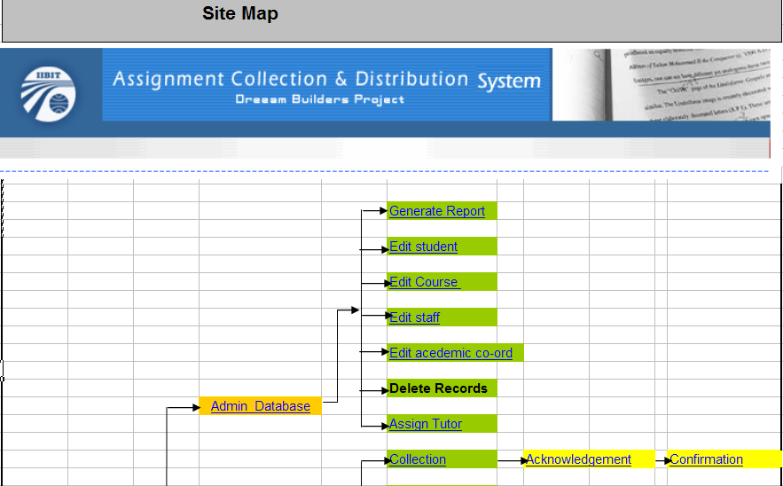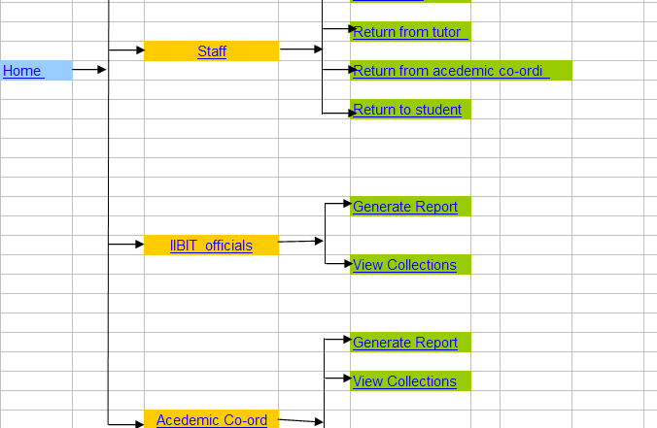

Security Issues
Some of the security issues with web site will be
- Hackers: By breaking into the website without permission
- Virus attacks:
Recommendations:
- Use of Firewalls
- Installation of Anti - virus software to protect the system from attack
- Use Anti Spy ware
- Backup copies of the website.

Navigational Systems

Navigation for the site will be done by the use of buttons on the side of the page. This will be available in all pages within the site.
The navigation will contain the following buttons that are linked to the relevant pages the navigational button is design for:

Global Navigation - Located on the page

- Log in: Takes the user to the main page.
- Sign out: Takes the user out from entire page.
- Help: Takes user to the Help Page.
- Student: To enter the student information
- Course: Selecting the particular course.
- Collection: For collecting the assignment.
- Distribution: Distributing the assignment.
- Tutor: Teacher who marking the assignment.
- Generate: Generating the assignment.
- Moderate: Selecting for moderation.
- Submit: Viewing the submitted assignment for marking or moderation.
- New task: For starting new task (submitting new assignment.)
- Sitemap: Takes users to the sitemap.

Content design

Types of content
The following sections will describe what type of contents will be used in the ACDS website,
Images
- GIF and JPEG are the main image formats used in the website
- Images must not clash with the overall theme of the website.
- Images must have links to the reference page of the website, where the images are referenced.
- Images must be at 180 x 120 pixel format.
Text
- Titles will be in the size of 14 with bold.
- Main texts are to be presented in font Century gothic, size 12, regular, black and left justified.
- Information is to be presented as bullet points with the maximum of eight bullet points, indented.

Design Constraints
There are restrictions regarding the design constrains.
Program un-availability
Some of our team members do not have the specific application at home so we have to come to the university and do that part of design and it is consume a lot more then actual time. Even it is possible that they couldn’t find computer.

Time limit
There is a possibility that to achieve final we need to work over time and consume more time than actually allocated.

Hardware Limitations
Enough space on server disk should be preserved to upload and make changes in future. If it will be not done it will be very risky to upload more content on site.

Prototypes
ACDS home page:

 |  | 

-----------------------------------------------------------------------------------------------------------------------------
 |  |  | Information Required
Please enter your Network Username, Network Password, and click 'Login' to proceed.
Username: 
Password:

This facility is only available to IIBIT staff and administrators. If you do not have a account, or you have forgotten your password, please contact the relevant helpdesk.
You must have your browser configured to accept cookies. You will have to reauthenticate if your session is idle for too long.
-----------------------------------------------------------------------------------------------------------------------------
© 2003 Infotech Professionals Pty Ltd. All rights reserved.
Infotech Professionals Pty Ltd.- Provider Cricos Code - 01917B
University of Ballarat at IIBIT (Sydney) - Provider Cricos Code - 01266K
University of Ballarat at IIBIT (Adelaide) - Provider Cricos Code - 02235J
-----------------------------------------------------------------------------------------------------------------------------

This page checks the user name and password and log into the user after checking the security and rights of the user.
.

Academic Coordinator page:
Top of Form
Sign Out | Help ?

-----------------------------------------------------------------------------------------------------------------------------
 |  |  | Unit Coordinator Page
Please Choose fromt he following options:

View Collection Information | 
Generate Report | 
Select Collection for Moderation | 
Top of Form

Bottom of Form

 | The Admin Page function allows users and the Website Administrator to add files and manage accounts to a system.
-----------------------------------------------------------------------------------------------------------------------------
© 2003 Infotech Professionals Pty Ltd. All rights reserved.
Infotech Professionals Pty Ltd.- Provider Cricos Code - 01917B
University of Ballarat at IIBIT (Sydney) - Provider Cricos Code - 01266K
University of Ballarat at IIBIT (Adelaide) - Provider Cricos Code - 02235J
-----------------------------------------------------------------------------------------------------------------------------

Bottom of Form
This page is for academic coordinator to view the assessment collection information, to generate report of collections and select collections for moderation.

DBAdmin page:
Sign Out | Help ?

----------------------------------------------------------------------------------------------------------------------------
Administrative Page
Please Choose from he following options:

Edit Student details | 
Edit Subject details | 
Edit Unit coordinator | 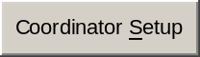
Edit Staff details | 
Assign Tutor to Unit | 
Delete records | 
Generate Report

The Admin Page function allows users and the Website Administrator to add files and manage accounts to a system.
----------------------------------------------------------------------------------------------------------------------------
© 2003 Infotech Professionals Pty Ltd. All rights reserved.
Infotech Professionals Pty Ltd.- Provider Cricos Code - 01917B
University of Ballarat at IIBIT (Sydney) - Provider Cricos Code - 01266K
University of Ballarat at IIBIT (Adelaide) - Provider Cricos Code - 02235J
----------------------------------------------------------------------------------------------------------------------------

The Administrative page give the database administrator enough facility to edit Student detail, edit Subject detail, Edit Unit Coordinator, Edit staff details, Assign tutors , Delete records and generate reports.

IIBIT Official page:
Sign Out | Help ?

-----------------------------------------------------------------------------------------------------------------------------
IIBIT Official Page
Please Choose fromt he following options:
View Collection Information
Generate Report

The Admin Page function allows users and the Website Administrator to add files and manage accounts to a system.
-----------------------------------------------------------------------------------------------------------------------------
© 2003 Infotech Professionals Pty Ltd. All rights reserved.
Infotech Professionals Pty Ltd.- Provider Cricos Code - 01917B
University of Ballarat at IIBIT (Sydney) - Provider Cricos Code - 01266K
University of Ballarat at IIBIT (Adelaide) - Provider Cricos Code - 02235J
-----------------------------------------------------------------------------------------------------------------------------

The IIBIT Official page gives the IIBIT officials opportunity to view collection information and to generate report.

Staff page:
Top of Form
Sign Out | Help ?

-----------------------------------------------------------------------------------------------------------------------------
 |  |  |  |  | Staff Page
 |  |  |  |  | Please Choose from the following options:
Collect New Assignment | 
Distribution of Collection | 
Process Tutor Return | 
Process Moderated Collection | 
Return to Student(s) | 

 |  |  |  | Bottom of Form
-----------------------------------------------------------------------------------------------------------------------------
© 2003 Infotech Professionals Pty Ltd. All rights reserved.
Infotech Professionals Pty Ltd.- Provider Cricos Code - 01917B
University of Ballarat at IIBIT (Sydney) - Provider Cricos Code - 01266K
University of Ballarat at IIBIT (Adelaide) - Provider Cricos Code - 02235J
-----------------------------------------------------------------------------------------------------------------------------
Bottom of Form

Stuff has the privilege to collect new assignment, distribute the assignment, process assessment after returning from Tutor, process moderation collection and return the assignment to the students.

Collection page:
Top of Form
Sign Out | Help ?

-----------------------------------------------------------------------------------------------------------------------------
 |  |  |  | Assignment Collection Page
Please Choose fromt he following options:
Select Stream
Select Subject
Select Assessment
Group Assessment
  Group | Individual
Number of Students

Top of Form

Bottom of Form

-----------------------------------------------------------------------------------------------------------------------------
© 2003 Infotech Professionals Pty Ltd. All rights reserved.
Infotech Professionals Pty Ltd.- Provider Cricos Code - 01917B
University of Ballarat at IIBIT (Sydney) - Provider Cricos Code - 01266K
University of Ballarat at IIBIT (Adelaide) - Provider Cricos Code - 02235J
-----------------------------------------------------------------------------------------------------------------------------
Bottom of Form

The collection page gives the user opportunity to select Stream, Subject, and Assessment, no of student and whether it is group or individual assessment using a set of drop down lists and check lists and interacting with the database. The ‘next‘ button takes the user to the “Assignment Collection detail” Page.

Collection detail:
Top of Form
Sign Out | Help ?

-----------------------------------------------------------------------------------------------------------------------------
Assignment Collection Page
Please Choose from the following options:
Enter Student ID


Top of Form
Student Name | Student ID #

Bottom of Form

-----------------------------------------------------------------------------------------------------------------------------
© 2003 Infotech Professionals Pty Ltd. All rights reserved.
Infotech Professionals Pty Ltd.- Provider Cricos Code – 01917B
University of Ballarat at IIBIT (Sydney) – Provider Cricos Code – 01266K
University of Ballarat at IIBIT (Adelaide) – Provider Cricos Code – 02235J
-----------------------------------------------------------------------------------------------------------------------------

This is the second stage of the assignment collection. The user will enter the student Id and then press done to go to the final stage of assignment collection. In case of group assignment user can enter the student Id of all the group members using the ‘Add next’ button. The name of the student and their Id is printed in the table.

Bottom of Form
Acknowledgement page:
Top of Form
Sign Out | Help ?

-----------------------------------------------------------------------------------------------------------------------------
Assignment Collection Page
Please Choose fromt he following options:
Enter Collection Code


Top of Form
Student Name | Student ID #

Bottom of Form

-----------------------------------------------------------------------------------------------------------------------------
© 2003 Infotech Professionals Pty Ltd. All rights reserved.
Infotech Professionals Pty Ltd.- Provider Cricos Code - 01917B
University of Ballarat at IIBIT (Sydney) - Provider Cricos Code - 01266K
University of Ballarat at IIBIT (Adelaide) - Provider Cricos Code - 02235J
-----------------------------------------------------------------------------------------------------------------------------
Bottom of Form

Finally the user will enter the collection code through the barcode scanner or manually entering in the text box.

View Collection page:

-----------------------------------------------------------------------------------------------------------------------------
 |  |  |  | View Collection
Select Subject Code
Select Assessment Code



-----------------------------------------------------------------------------------------------------------------------------
© 2003 Infotech Professionals Pty Ltd. All rights reserved.
Infotech Professionals Pty Ltd.- Provider Cricos Code - 01917B
University of Ballarat at IIBIT (Sydney) - Provider Cricos Code - 01266K
University of Ballarat at IIBIT (Adelaide) - Provider Cricos Code - 02235J
-----------------------------------------------------------------------------------------------------------------------------

User can select subject code and assessment code from a set of drop down list and the ‘submit’ button print the list of collection of that particular assessment in display.

Edit Staff page:
Top of Form

-----------------------------------------------------------------------------------------------------------------------------
 |  |  |  | Edit Staff
Please Choose from the following options:
Top of Form
Staff Id : 

Bottom of Form
 |  |  |  | 
-----------------------------------------------------------------------------------------------------------------------------
© 2003 Infotech Professionals Pty Ltd. All rights reserved.
Infotech Professionals Pty Ltd.- Provider Cricos Code - 01917B
University of Ballarat at IIBIT (Sydney) - Provider Cricos Code - 01266K
University of Ballarat at IIBIT (Adelaide) - Provider Cricos Code - 02235J
-----------------------------------------------------------------------------------------------------------------------------

User can enter the Staff Id and proceed to the next step.

Bottom of Form

Edit assessment page:
Top of Form

-----------------------------------------------------------------------------------------------------------------------------
 |  |  |  | Edit Assessment
Please Choose from the following options:
Top of Form
Enter Subject code: 

Bottom of Form
 |  |  |  | 
-----------------------------------------------------------------------------------------------------------------------------
© 2003 Infotech Professionals Pty Ltd. All rights reserved.
Infotech Professionals Pty Ltd.- Provider Cricos Code - 01917B
University of Ballarat at IIBIT (Sydney) - Provider Cricos Code - 01266K
University of Ballarat at IIBIT (Adelaide) - Provider Cricos Code - 02235J
-----------------------------------------------------------------------------------------------------------------------------

User can enter the subject code and proceed to the next step of edit assessment.

Distribution page:
Sign Out | Help ?

-----------------------------------------------------------------------------------------------------------------------------
 |  |  |  | Assignment DistributionPage
Please Choose from the following options:
Select Stream
Select Subject
Select Assessment
Select Tutor/Lecturer


-----------------------------------------------------------------------------------------------------------------------------
© 2003 Infotech Professionals Pty Ltd. All rights reserved.
Infotech Professionals Pty Ltd.- Provider Cricos Code - 01917B
University of Ballarat at IIBIT (Sydney) - Provider Cricos Code - 01266K
University of Ballarat at IIBIT (Adelaide) - Provider Cricos Code - 02235J
-----------------------------------------------------------------------------------------------------------------------------

The user can Assignment distribution by selecting the Stream, Subject, Assessment and Tutor/Lecturer from a set of drop down list and the ‘next’ button takes the user to the “Assignment Distribution Page”.

Distribution Detail page:
Sign Out | Help ?

-----------------------------------------------------------------------------------------------------------------------------
Assignment DistributionPage
Please Choose from the following options:
Enter Collection Code

-----------------------------------------------------------------------------------------------------------------------------
© 2003 Infotech Professionals Pty Ltd. All rights reserved.
Infotech Professionals Pty Ltd.- Provider Cricos Code - 01917B
University of Ballarat at IIBIT (Sydney) - Provider Cricos Code - 01266K
University of Ballarat at IIBIT (Adelaide) - Provider Cricos Code - 02235J
-----------------------------------------------------------------------------------------------------------------------------

User will enter the collection code via the barcode scanner or entering manually in the text box and the ‘Done’ button finishes the assessment distribution process. The ‘Add Next’ button gives the user privilege to assign more assessment to the same Tutor or Lecturer just entering the assessment code.

Distribution Return page:
Top of Form

-----------------------------------------------------------------------------------------------------------------------------
Return Form Tutor/Lecturer
Please Choose from the following options:
Select Stream
Select Subject
Select Assessment
Select Tutor/Lecturer

Bottom of Form
-----------------------------------------------------------------------------------------------------------------------------
© 2003 Infotech Professionals Pty Ltd. All rights reserved.
Infotech Professionals Pty Ltd.- Provider Cricos Code - 01917B
University of Ballarat at IIBIT (Sydney) - Provider Cricos Code - 01266K
University of Ballarat at IIBIT (Adelaide) - Provider Cricos Code - 02235J
-----------------------------------------------------------------------------------------------------------------------------
Bottom of Form

The user can process the distribution return from the tutor or lecturer selecting the Stream, Subject, Assessment and Tutor/Lecturer from a set of Dropdown list and the ‘Next’ button takes the user to the “Return Collection Page”.

Moderation Page:
Top of Form

-----------------------------------------------------------------------------------------------------------------------------
Return Form Tutor/Lecturer
Please Choose from the following options:
Select Stream
Select Subject
Select Assessment
Select Tutor/Lecturer

Bottom of Form
-----------------------------------------------------------------------------------------------------------------------------
© 2003 Infotech Professionals Pty Ltd. All rights reserved.
Infotech Professionals Pty Ltd.- Provider Cricos Code - 01917B
University of Ballarat at IIBIT (Sydney) - Provider Cricos Code - 01266K
University of Ballarat at IIBIT (Adelaide) - Provider Cricos Code - 02235J
-----------------------------------------------------------------------------------------------------------------------------
Bottom of Form

The user can process Assignment moderation by selecting the Stream, Subject, Assessment and Tutor/Lecturer from a set of drop down list and the ‘next’ button takes the user to the “Assignment Distribution Page”.

Report:
Top of Form
Sign Out | Help ?

-----------------------------------------------------------------------------------------------------------------------------
Generate Report Page
Please Choose from the following options:
Select Stream
Select Subject
Select Assessment


Bottom of Form
-----------------------------------------------------------------------------------------------------------------------------
© 2003 Infotech Professionals Pty Ltd. All rights reserved.
Infotech Professionals Pty Ltd.- Provider Cricos Code - 01917B
University of Ballarat at IIBIT (Sydney) - Provider Cricos Code - 01266K
University of Ballarat at IIBIT (Adelaide) - Provider Cricos Code - 02235J
-----------------------------------------------------------------------------------------------------------------------------
Bottom of Form

The report of an individual assessment can be processed from this page. User can select the Stream, Subject and Assessment from a set of drop down list and the 'View report’ button displays the report.

Returning Codes page:
Top of Form

-----------------------------------------------------------------------------------------------------------------------------
 |  |  |  | Enter Collection Codes
Please Choose from the following options:
Enter Collection Code

Bottom of Form
-----------------------------------------------------------------------------------------------------------------------------
© 2003 Infotech Professionals Pty Ltd. All rights reserved.
Infotech Professionals Pty Ltd.- Provider Cricos Code - 01917B
University of Ballarat at IIBIT (Sydney) - Provider Cricos Code - 01266K
University of Ballarat at IIBIT (Adelaide) - Provider Cricos Code - 02235J
-----------------------------------------------------------------------------------------------------------------------------
Bottom of Form

The user can enter the collection codes through the barcode scanner or entering manually in the text box and the ‘Done’ button finishes the process of returning assessment to the base.

Submission Return page:
Top of Form

-----------------------------------------------------------------------------------------------------------------------------
Return To Student
Please Choose from the following options:
Select Stream
Select Subject
Select Assessment
Enter Collection Code


Bottom of Form
-----------------------------------------------------------------------------------------------------------------------------
© 2003 Infotech Professionals Pty Ltd. All rights reserved.
Infotech Professionals Pty Ltd.- Provider Cricos Code - 01917B
University of Ballarat at IIBIT (Sydney) - Provider Cricos Code - 01266K
University of Ballarat at IIBIT (Adelaide) - Provider Cricos Code - 02235J
-----------------------------------------------------------------------------------------------------------------------------
Bottom of Form

Finally the user can return the assignment to the student, The ‘Update’ button finishes this process. The user can select the assignment using a set of drop down list and entering the barcode through barcode scanner or manually entering the barcode in the text box provided.

Backup and recovery strategy

Backups
Copies of programs, databases, other files etc. are made with the purpose to restore information in case of loosing it, for instance, because of a computer failure or a virus infection or system crash. For all of this back up is necessary for saving the original work. This sections deals with what should be backed up, how often, how and where. The system administrator will be responsible for the system’s backup. The elements that are needs to be backed up are given below,

Objects/System Elements

- Database
- Source code
- Compiled code
- Documentation
- Configuration files

The following steps determine the Back up schedule,
Daily back up
We have to specify the specific directories for daily backup. In this way the backup should be done into a zip archive. We can set filters to handle only certain file types, or to confine the backup to certain file types only. Then it watches the operating system, and marks a directory as "ready for backup" on each file creation or modification.
These files, which have not been changed of modified, will not be backed up and this can save considerable space and time. A complete restoration of a damaged files system will them require the last full backup followed by the incremental backup.
We can specify when to back up our important document or file,
- As soon as we change a file.
- At fixed time period.
- When the screen saver is running.
- On the end of the session
- At a fixed time.
Full back up-weekly
Full backup is the starting point for all other backups, and contains all the data in the folders and files that are selected to be backed up. Because the full backup stores all files and folders, frequent full backups result in faster and simpler restore operations. Remember that when you choose other backup types, restore jobs may take longer.

Mechanism
These are available options that depend on considerations that should be done by the server administrators. Commonly used mechanisms can include:
- Physical - Network system backups, raw partition backups
- Logical - Data exports

Hardware level backup strategies can include
- RAID (Redundant array of Independent Disks) compliant hard disks
- Disk mirroring
- Clustering
- Hot swaps - mirroring at server level

Advantages
- Restore is the fastest
Disadvantages
- Backing up is the slowest
- The storage space requirements are the highest

Back up medium
The recommended backup media for the data backups are tape and autoloader. Data may also be backed up to pipes or file·
But when we just think about the security of important set of documentation and other system files the following would be the better medium for that,

- Removable Hard disk
- CD ROM
- DVD
- USB Memory

Recovery strategies
Recovery is the decisions and actions that taken after a disaster with a view to restoring and improving the necessary files and documentation by reducing the disaster risk.

File System Corruption
There are many ways that the file structures used to contain programs and data on the hard disk can become damaged. In some cases, this corruption can result in data loss, especially if the disk is not maintained properly and the file system scanned on a regular basis.
If the files corrupted are database files then stop web server connections, detach the database from the SQL server management console and recover from the backup media the backed up files. Re-attach the database and restart the web server.

Hardware failure
The risk of hardware failure is the most commonly talked-about reason to perform backups. Indeed, nothing will jolt someone into realizing the importance of backups more than an unrecoverable hard disk failure.
If any of the hardware stops working then you need to replace the hardware or fix the hardware. If the hardware is under warranty then contact the vendor. After replacing of fixing the hardware connect it back to the system and restore the backed up files and test.

Data Corruption
Restore the latest transaction list from SQL Server or in case of a vast damage restore a backed up copy of the database.

Test plans and procedures
The testing strategy should define the objectives of all test stages and the techniques that apply. The testing strategy also forms the basis for the creation of a standardized documentation set, and facilitates communication of the test process and its implications outside of the test discipline. Any test support tools introduced should be aligned with, and in support of, the test strategy.

Client will be asked to test the system and give feedback if the system does not meet all the requirements of the client. Testing will be done regularly and feedback will be documented for the further development of the system. The production test will be done on the complete application after the deployment.
Test plan consists of following,
- the items to be tested,
- the testing to be performed,
- test schedules,
- resource and facility requirements,
- reporting requirements,
- evaluation criteria,
- Risks requiring contingency measures?

What to test
- Admin login and permissions
- Staff member login and permissions
- Test the property pages and the correct display of the pages.
- The navigation and outlook of the web interface
- Check the functionality of the software
- Test if the system generates the E-mail and allows users to use the features of the software.
- Connections to the database and the queries.

It is essential that sufficient time and suitable resources are dedicated to testing and commissioning to assure the fundamental success of the project. There are advantages in using dedicated, specialist resources i.e. independent of the development / construction team and the project sponsor should ensure that testing requirements are considered throughout the project lifecycle and a suitable test strategy and appropriate test plans are formulated and instantiated.

Acceptance plan

Installation

The installation will be done on a Ballarat server provided for that particular use or on a machine inside the university that can be accessed from Internet.

Acceptance Testing
An acceptance test is the process of the user testing the system and, based on the results, either granting or refusing acceptance of the software/system being tested. It is often referred to as functional testing, beta testing, QA Testing, application testing, or end user testing. It is also sometimes split into factory acceptance testing and site acceptance testing, the first being run in-house, the second at the customer's site.

The client should provide feedback during the test phase and using change request form available from the Team’s website. The communication between clients and team members will be held through emails or in a weekly meeting. The acceptance should be written and signed by the client before the presentation of the final product.

Acceptance criteria
Minimum standards for the content of programs, plans, procedures, and designs are required by a specification for the performance of a contract. Acceptance Criteria is the basis for judging the responsiveness of a contractor’s program and is used as a basis for suspending work, if necessary.

The acceptance criteria for the web based software and ACDS system is the following,

- All core functional requirements are implemented
- All non-functional requirements are satisfied.
- User Documentation has been provided.
- All the user guides have been provided.
- User sign off needed
The software meets all the performance requirements.

